**Create a table company**

**use company;**

**create table Sales(**

**saleid int primary key auto_increment,**

**productid int,**

**customerid int,**

**saledate date,**

**quantity int,**

**unitprice int,**

**region varchar(20));**

**insert into Sales(productid,customerid,saledate,quantity,unitprice,region)**

**values(101,1001,"2024-01-05",5,200,"North"),**

**(102,1002,"2024-01-10",10,150,"East"),**

**(103,1003,"2024-02-15",2,300,"North"),**

**(104,1004,"2024-02-20",7,250,"West"),**

**(101,1005,"2024-03-05",1,200,"East");**

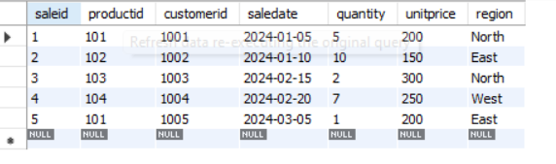

**# Q1- Query to calculate the total sales (Quantity * UnitPrice) for each product.**

**Select productid, Sum(quantity*unitprice) As 'Total Sales' from sales group by productid;**

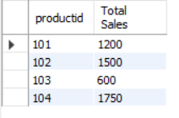

**# Q2- Query to find the total number of products sold in each region.**

**Select region,sum(quantity) AS 'Total Product Sold' from sales group by region;**

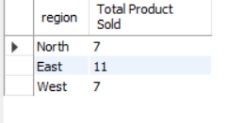

**# Q3- Query to get the average sales amount per product.**

**Select productiD,avg(quantity*unitprice) AS "Average Sales" from sales group by productid**;

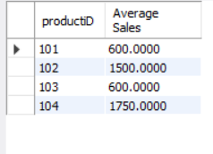

**# Q4- Regions where total sales are more than 3000.**

**Select region, sum(quantity*unitprice) AS "Total Sales" from sales group by region having sum(quantity*unitprice)>3000;**

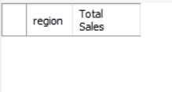

**# Q5- Query to get the maximum quantity sold for each product.**

**Select productid,max(quantity) AS "Maximum Quantity Sold" from sales group by productid;**

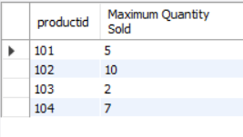

**# Q6- Query to calculate the average quantity of products sold per region.**

**Select region,avg(quantity)from sales group by region;**

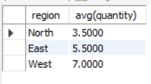

**# Q7- Find the product IDs that have generated a total sales amount of more than 1000.**

**Select productid, sum(quantity*unitprice) from sales group by productid having sum(quantity*unitprice)>1000;**

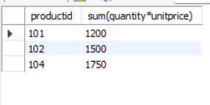

**# Q8- Query to get the total number of sales (rows) made for each customer.**

**Select customerid, count(*) As "Total Sales" from sales group by customerid**;

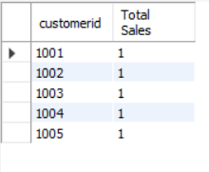

**# Q9- Find the products for which the average quantity sold is less than 5.**

**Select productid , avg(quantity)from sales group by productid having avg(quantity)<5;**

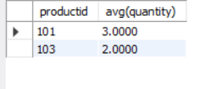

**# Q10- Query to find the sum of total sales for each customer in each region.**

**Select customerid,region, sum(quantity*unitprice) AS "Total Sales" from sales group by customerid,region;**

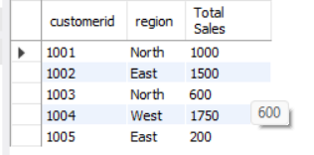

**# Q11- Query to calculate the total sales for each month.**

**Select month(saledate), sum(quantity*unitprice) AS "Total Sales" from sales group by month(saledate);**

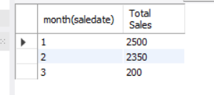

**# Q12- Find the regions where the average unit price is more than 200.**

**Select region,avg(unitprice) from sales group by region having avg(unitprice)>200;**

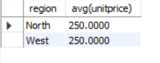

**# Q13- Query to get the minimum and maximum quantity sold per region.**

**select region, min(quantity) as "Minimum quantity sold",max(Quantity) as "Maximum Quantity Sold" from sales group by region;**

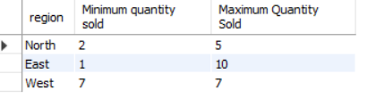

**# Q14- Find the customers who have made more than 2 purchases.**

**select customerid from sales group by customerid having count(*)>2;**

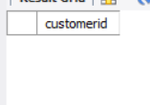

**# Q15- Query to find the total sales for each product and filter only those products where the total sales exceed 1500.**

**Select productid, sum(quantity*unitprice) as"Total Sales" from sales group by productid having sum(quantity*unitprice)>1500;**

